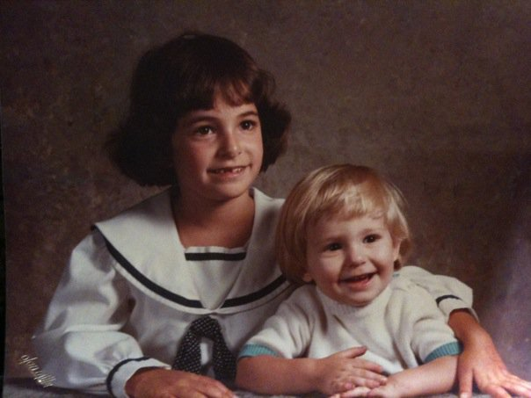In this project, I will get to know a lot about you, while you learn a lot about digital pictures and creating exciting slide shows using Photo Story. (By the way, “a lot” is ALWAYS 2 words- Never write it as “alot.”) Follow the directions and triple check your requirements/rubric to earn the maximum amount of points for this project.
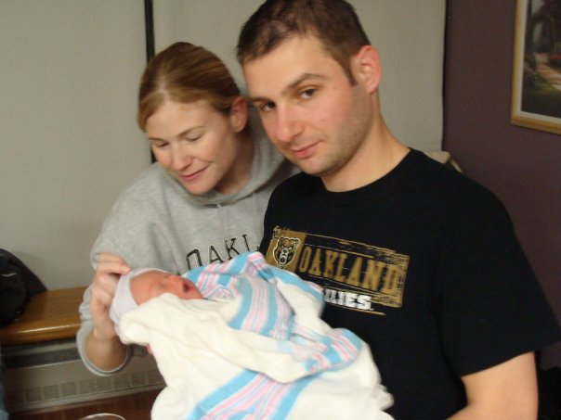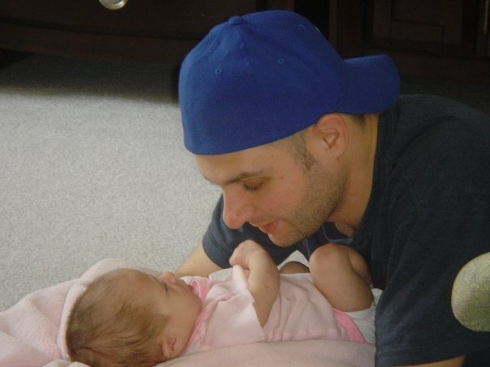

Directions-
Step 1- Create a storyboard has 20 to 25 images of you and/or things that interest you or tell me something about you.
Step 2- Create a folder on your v:drive titled “Montage of Me Images.”
Step 3- Import 20 to 25 images into the folder you created. You can get these from the internet, a flash/jump drive, a camera you bring in, or you can send them to yourself through an email .
Step 4- Open Photo Story 3 in your programs menu.
Step 5- Import all of your pictures for this project.
Step 6- Follow the Requirements Table on the back to make sure you complete all things necessary to get full points for this project. This should be an easy, fun A+!!!
* Make sure to use your tutorial reference sheet to find information about how to complete certain tasks.
Triple check the “Must Haves” below so you get an A+!
Must Have: | Points Possible | Points Earned and Comments
A story board that is approved by Mr. Gulecki. Bring the board to Mr. Gulecki first! | 5
At least 20 pictures/slides | 10
At least 10 captions/titles that are easy to read and located in different areas. (Try different colors, locations, fonts, & sizes.) | 10
Length of Story is between 60 & 100 seconds (1 to 1:40 min.) | 5
Proper grammar/spelling on captions/titles | 5
Music Clip(s) and/or voiceover on all slides | 5
At least 5 different picture effects. | 5
At least 10 different “Motions” and/or special transitions | 10
Saved in correct folder (v: drive) and uploaded properly as a WMV file. | 5
TOTAL: | 60

After you upload your project, turn this sheet into the inbox.
Staple your story board to the sheet.

